**Packet Sniffing Using WireShark**

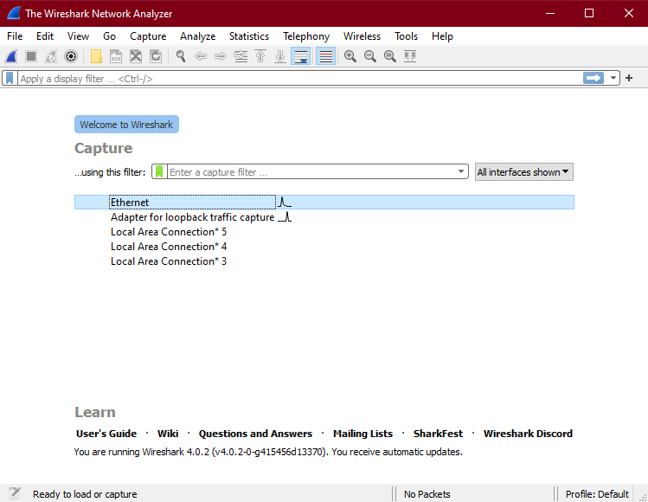

-After installing Wireshark, we’re going to choose the network adapter to capture the packets from.

-And I choose Ethernet (because the connection is through ethernet).

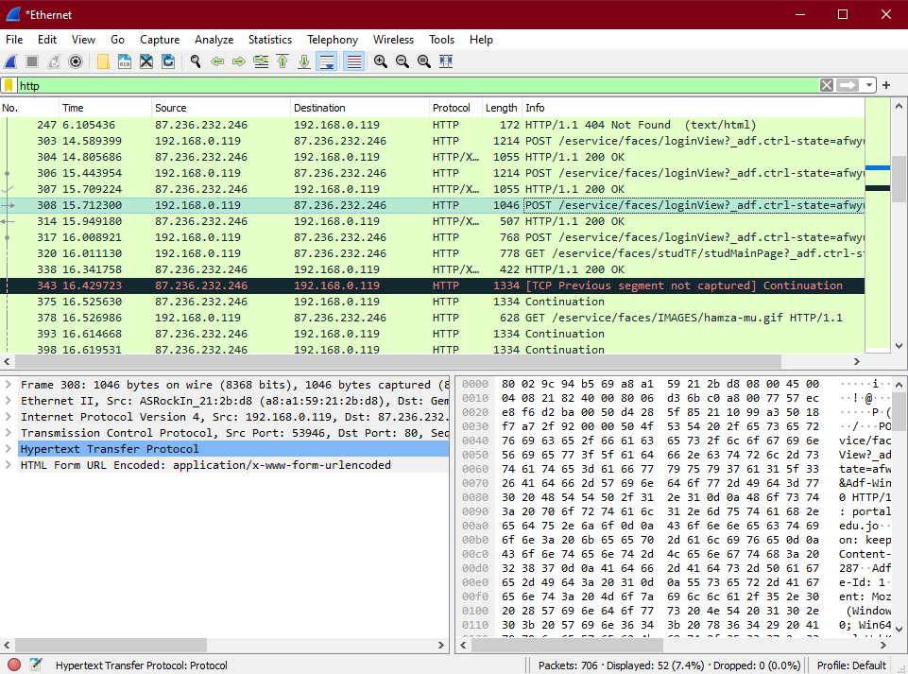

-The Capture will begin.

-Then I opened a new tap then go to eservices : <http://portal1.mutah.edu.jo/eservice/faces/loginView?_adf.ctrl-state=prxy7jil9_3>

to start inspecting packets.

-After that I typed “HTTP” in Capture filter to show only HTTP protocol packets information.

-Then I selected the target packet (POST).

-Then analyze -> Follow TCP Stream to show the data more uniformly.

-Here is the packet information

- And my target is to get the number and password as shown.

-I also did inspect the DNS protocol packets as shown.